LOCATION : NATIONWIDE
DATE : 27.10.2017
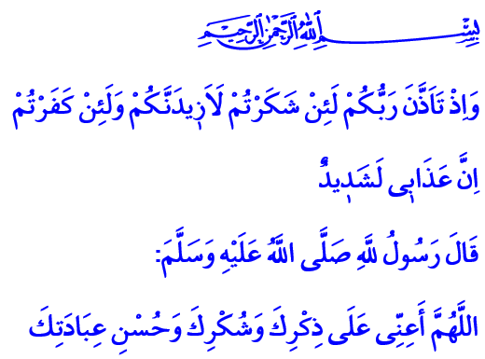
TO BE A GRATEFUL SERVANT
Blessed Friday to You, Brothers and Sisters!
Our Prophet (pbuh) occasionally woke up at night and prayed. He stood humbly in qiyam (standing) position for a long time. He prostrated in tears. He prayed to Allah most sincerely. Our mother Aisha witnessed his dedication in awe and asked him: “O Messenger of Allah! Why do you pray this much even though your God has forgiven your sins in the past and the future?” Allah’s Messenger (pbuh) gave this meaningful and wise answer to his dear wife: “Should I not be a thankful servant, O Aisha?”
Honorable Believers!
We are mere guests in this mortal world. We see the blessings of Allah everywhere we look. We taste His blessings with every bite. We live the life He granted us with each breath. We know that these are all bestowed on us.
Let us stop for a moment and remember the blessings we had in just the last few hours. Let us think about how we reached with each one of those blessings. If that blessing was the fruit of a tree that came from deep inside the earth, that means Allah had prepared it through several phases for us. If it was a drop of water, that means Allah had raised it from the oceans to the clouds, then made it come down to earth just for us. If it was the light, then Allah had sent it from deep down the space through the Sun.
Brothers and Sisters!
After we saw all these blessing of our Lord Almighty, let’s see where that feeling of gratitude that encircles us would take us! Then we will see that being grateful has a special place among all these blessings that our Lord granted us. For this reason, our Lord Almighty enjoins: “Whoever gives thanks, he gives thanks for (the good of) his ownself. And whoever is unthankful, then verily, Allah is All-Rich (Free of all wants), Worthy of all praise.”
Honorable Brothers and Sisters!
Gratitude is appreciating the blessings that Allah bestowed on us. Gratitude is protecting ourselves from being a slave to our desires and wants, ambition and greed. Gratitude is a sign of living on the path of purpose and wisdom of creation. Gratitude is not to become deaf and blind to the good deeds of people towards us. Gratitude also requires patiently enduring the poverty, aside from appreciating the wealth. Gratitude is seeking refuge in Allah’s mercy from his wrath, keeping this verse in mind: “And (remember) when your Lord proclaimed: ‘If you give thanks, I will give you more, but if you are thankless, verily! My Punishment is indeed severe.’”
Dear Brothers and Sisters!
Being grateful does not equal saying “Praise to Allah, thanks be to our Lord”. The real gratitude is using each blessing in a way that would win Allah’s countenance. Every breath we take, our life, mind, health and all other blessings have a specific gratitude.
The gratitude for being created as an honorable human is faith. The gratitude of our hearth is to drive away hate, grudge and other bad feelings from it. The gratitude of our mind is to contemplate and consider the holiness of Allah. The gratitude of our tongue is mentioning Allah. The gratitude of our body is always living in accordance with Allah’s countenance and doing our prayers. The gratitude of our wealth and possessions is to give alms and zakat to the needy. The gratitude of our knowledge is to be helpful to mankind by educating students and producing lasting works.
Honorable Believers!
Every one of us feel the need to thank a person for his kindness, even if it’s a small one. Therefore, do you think it would be appropriate to keep ourselves from being grateful to our Lord, Who granted us all these blessings? Would ignoring these blessings be in accordance with the sense of servitude and the moral of a believer? Of course not.
My brothers and sisters! Let’s not deprive our minds, hearts, tongues and bodies from the blessing that is gratitude. May our life be blessed with our gratitude. May our gratitude be the reason for more blessings. May our praise get us closer to our Lord and elevate us.
Let me conclude this khutba with a prayer of our Prophet (pbuh): “O Allah, help me in remembering You, in giving You thanks, and worshipping You well.”

Müslim, Characteristics of The Hypocrites And Rulings Concerning Them, 81; İbn Hıbban, Sahih, II, 36.
Al Luqman, 31/12.
Ibrahim, 14/7.
Abi Dawud, Prayer (Kitab Al-Salat): Detailed Injunctions about Witr 26. Written by: General Directorate of Religious Services

